Instructions for Logging on to Formed
For the Opening the Word Videos

- Christ on the Mountain has invested in a subscription to Formed for its members. This requires a one-time “registration”. To begin, visit the Formed website (https://formed.org) and click “Sign up as a parishioner”:

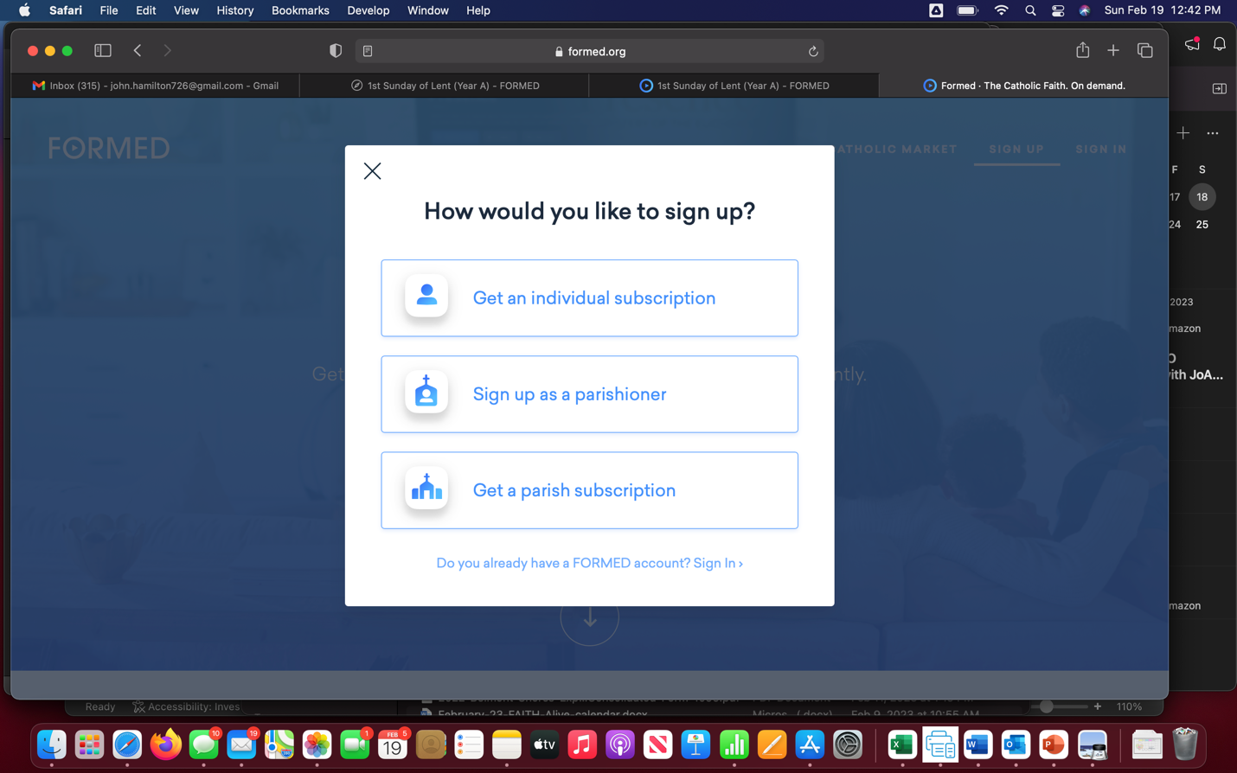

- In the “Find your Parish or Organization” box, start typing “Christ on the Mountain” and then click on the entry presented – it should show COTM’s address next to it.

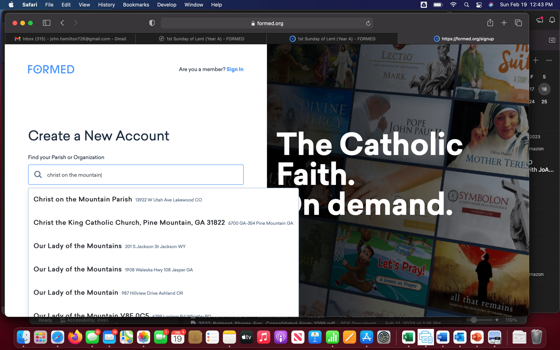

- Click Next:

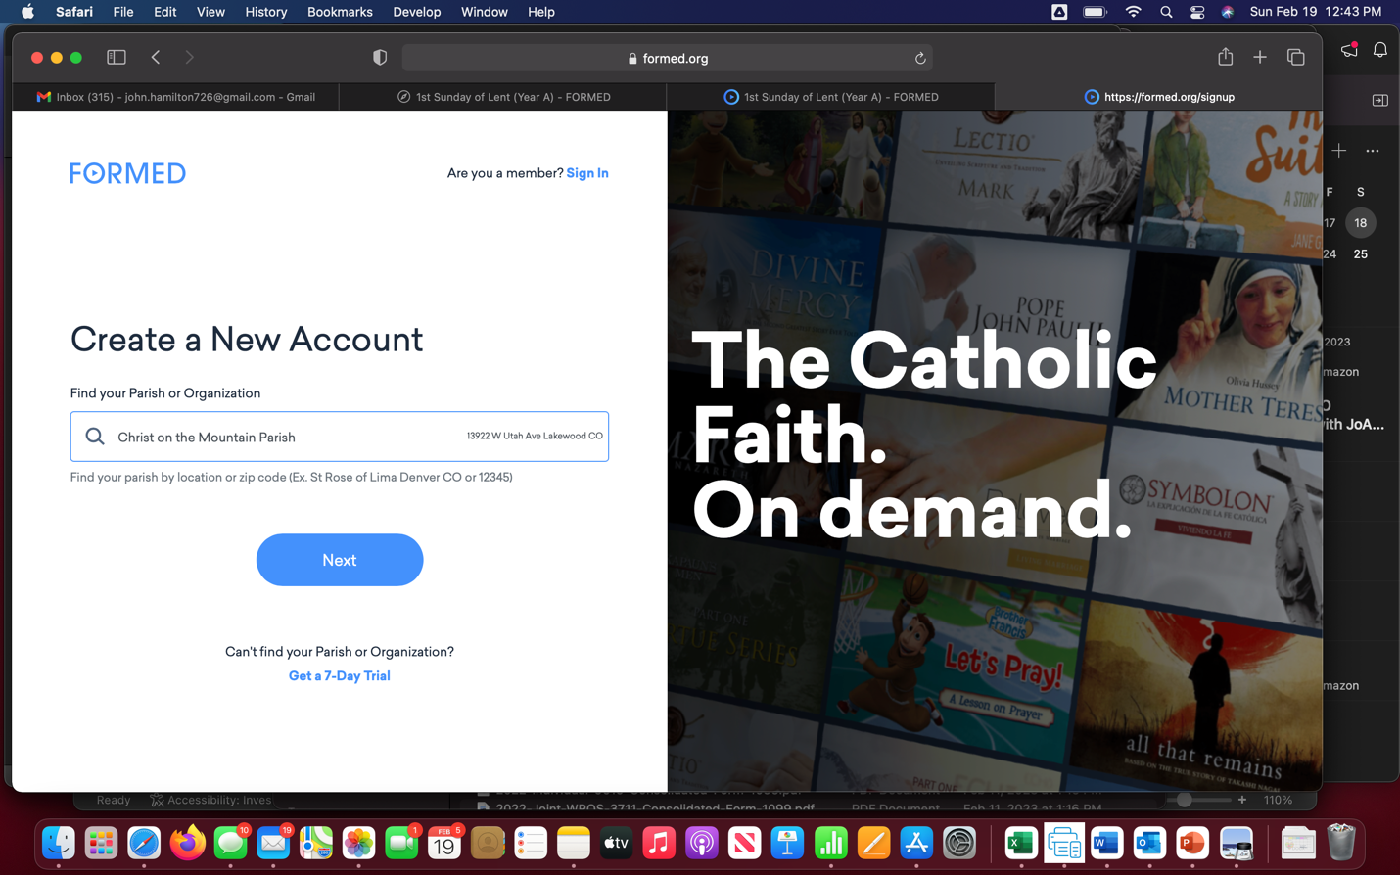

- Complete the entries in the “Create a New Account” screen with your information. Example:

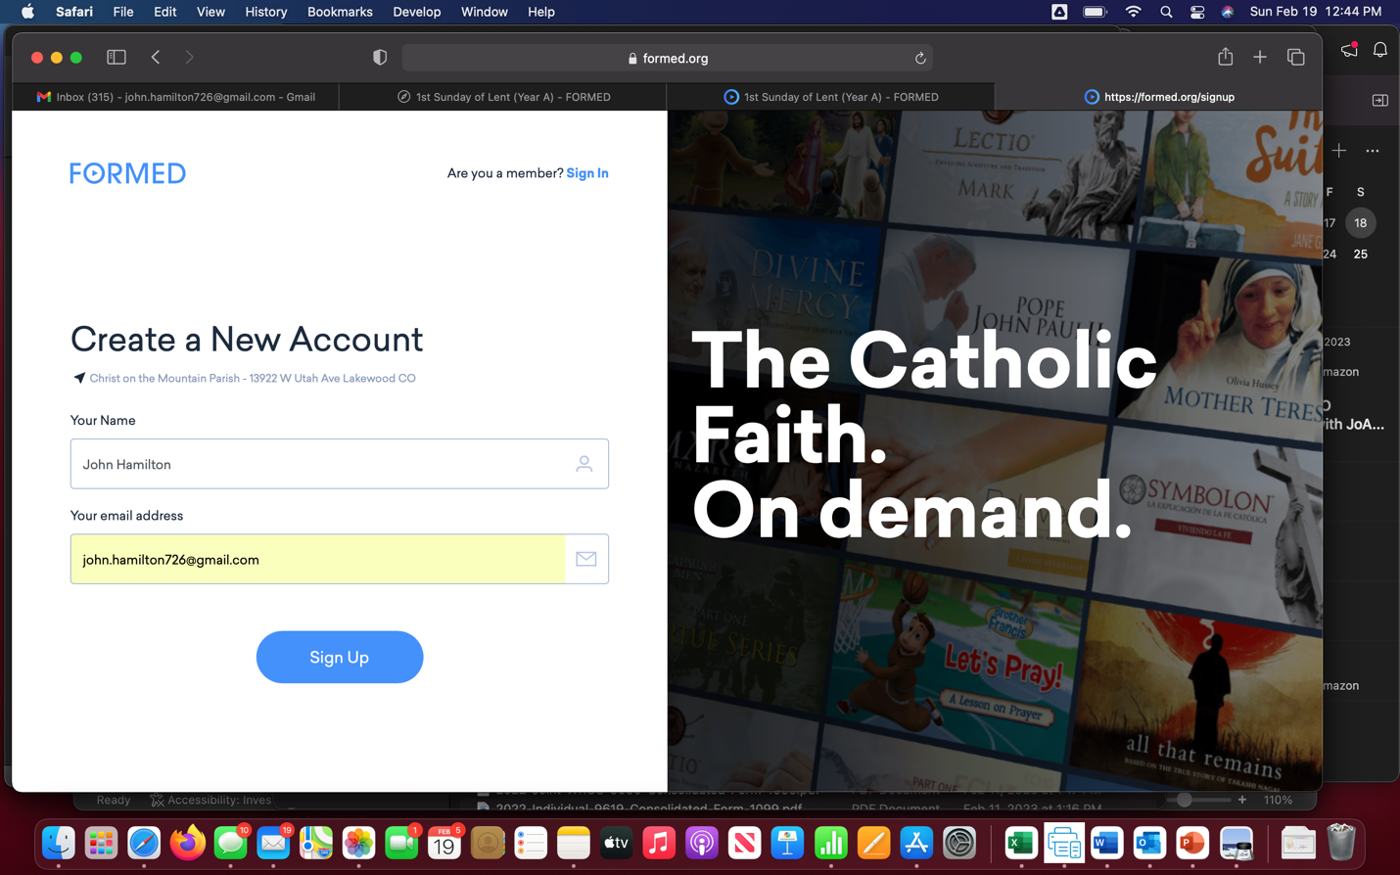

- Now that you’ve “registered”, you can click the link that will be provided in Kelly Hamilton’s weekly email to get to the Opening the Word video. If, after clicking that link, you go directly to the video, you’re good to go. If not, read on…

- After you click the link, you should be presented with a screen that looks something like the below. If you see the message about cookies, click "Accept" and click "Sign in" next to the "Already subscribed?" label:

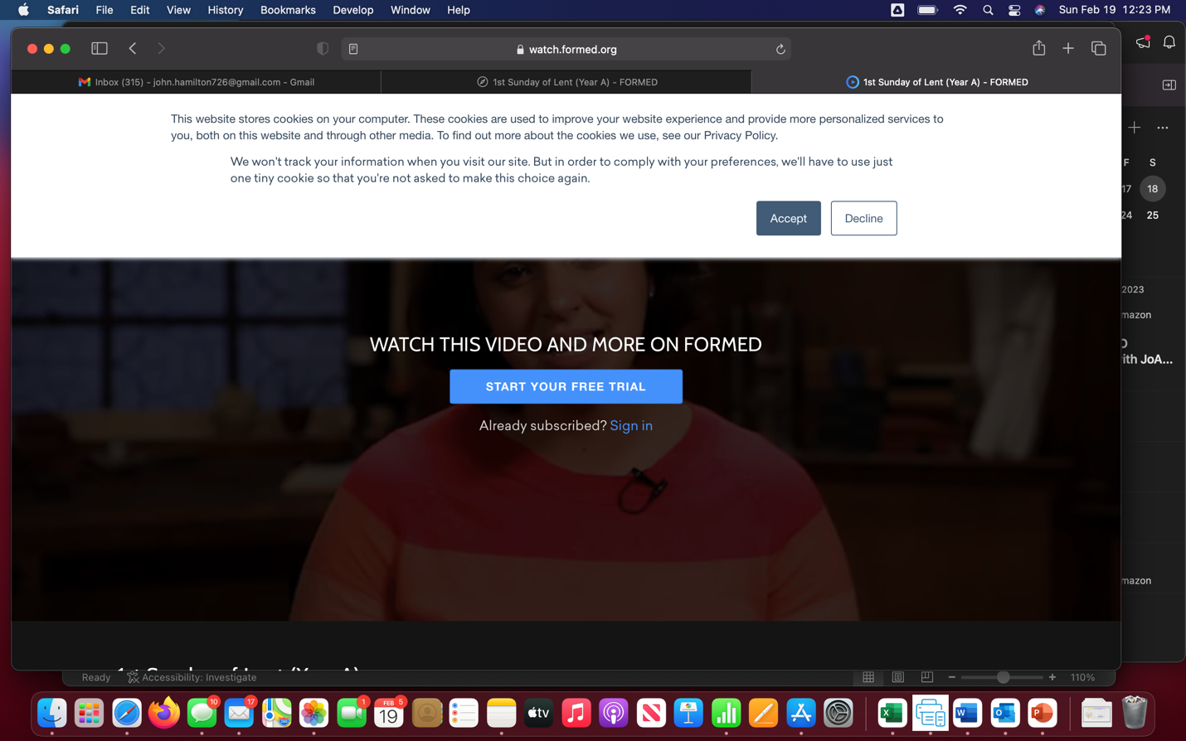

- Enter your email address and click Next. Example:

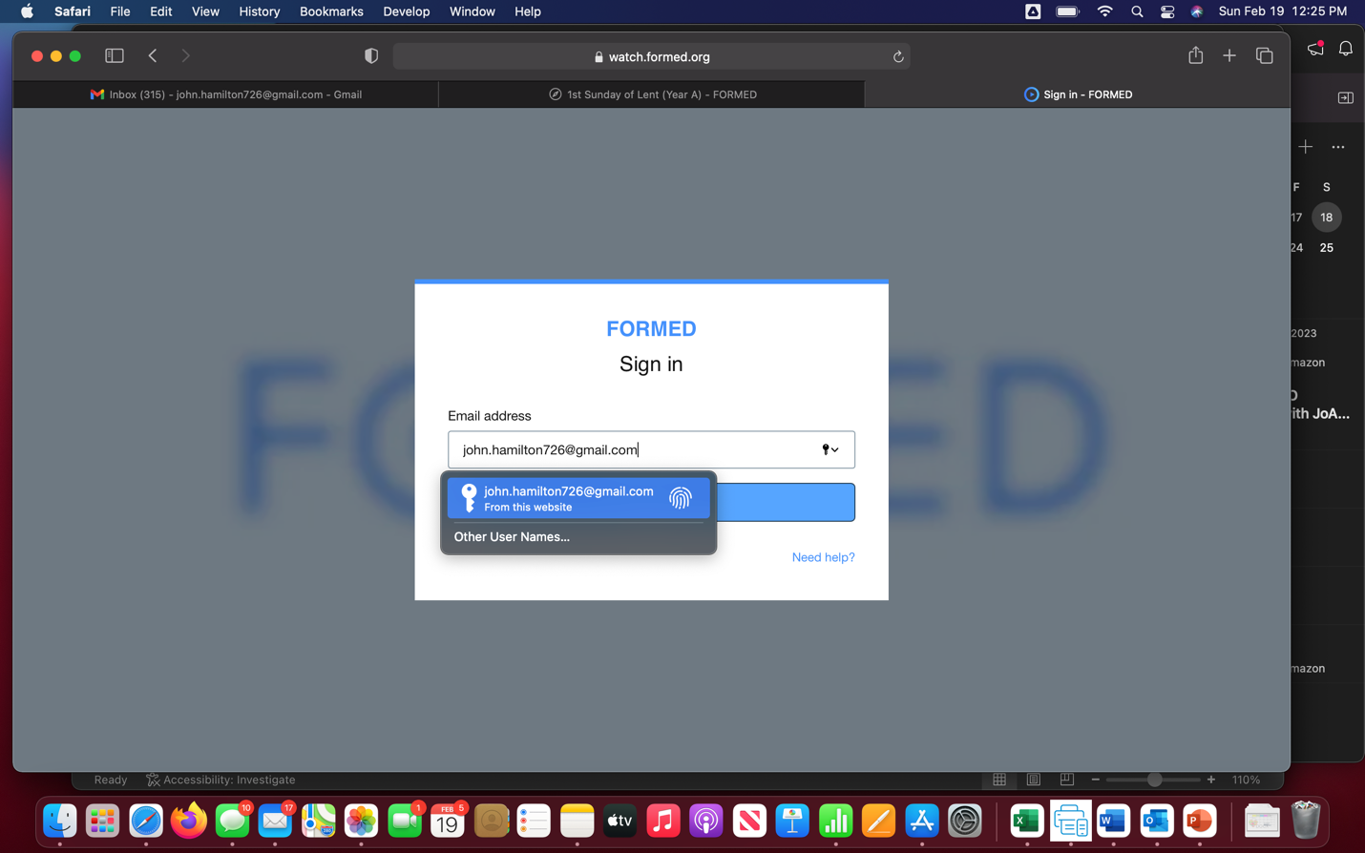

- You should be presented with this screen:

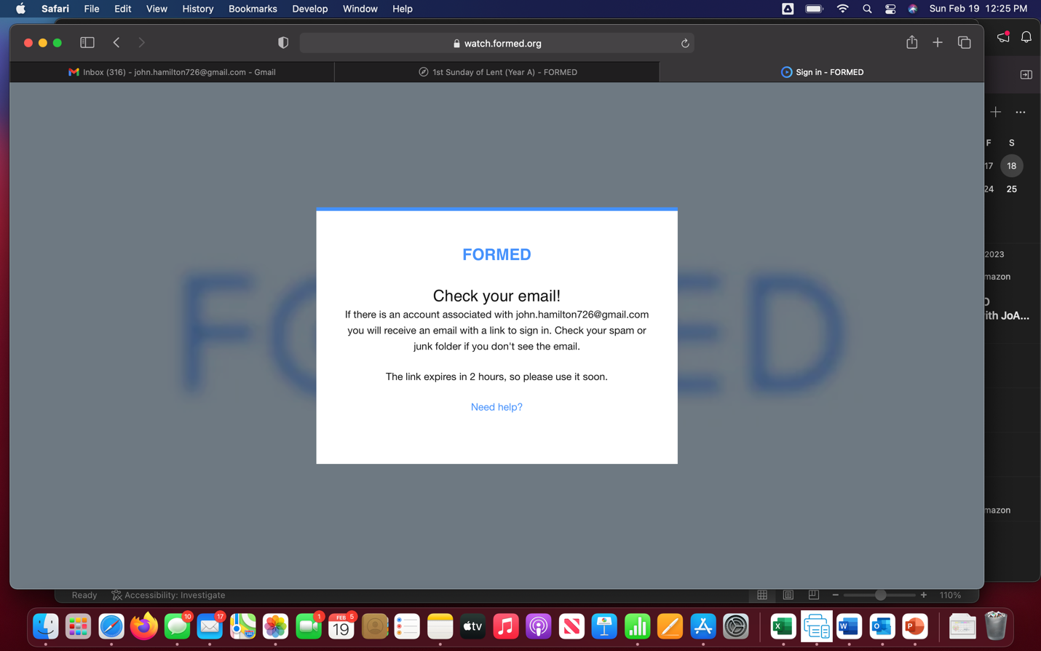

- Go to your email and look for the message from FORMED. Note that it might be in your spam/junk folder. Click “Sign in now”:

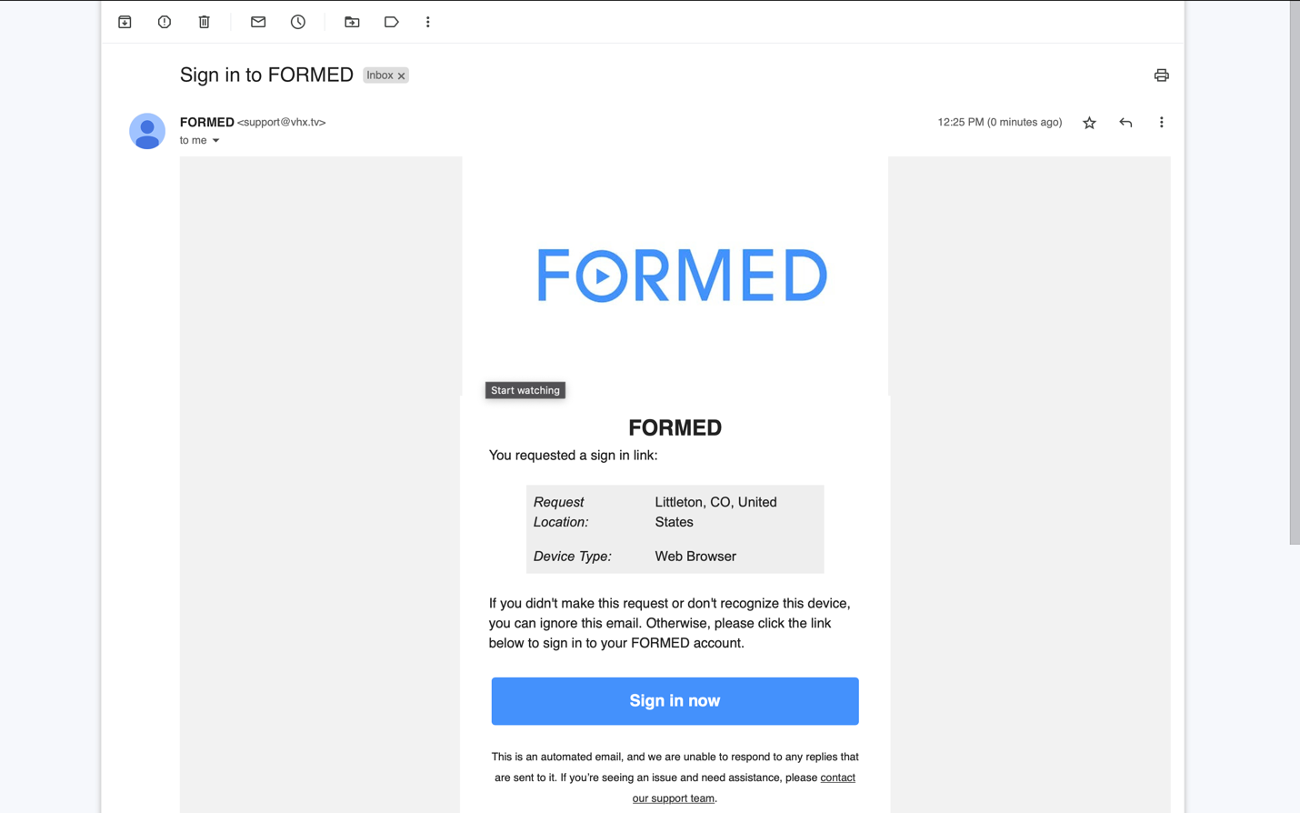

- Click Continue:

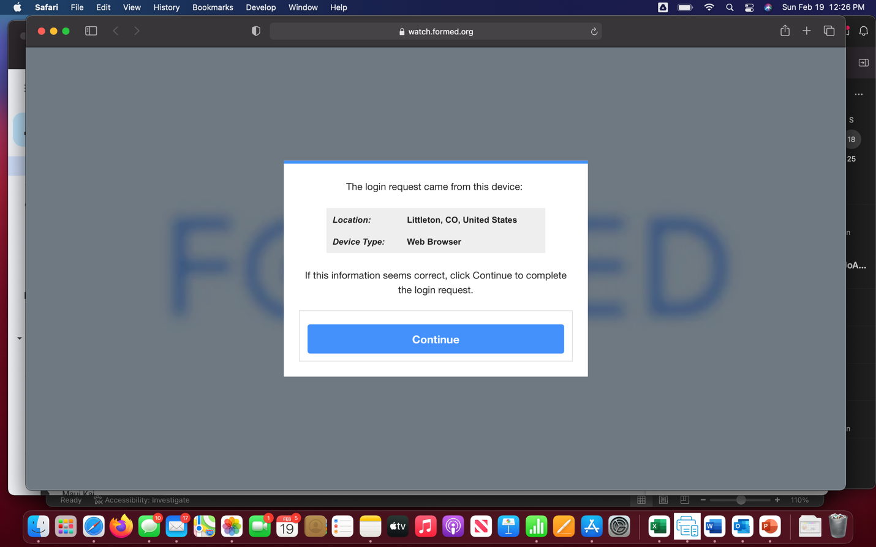

- At this point, you should be presented with the video.
- Notes:
  - Unless you clear your browser’s history/cache, the next time you click on a link to an Opening the Word video, you should go directly to that video without having to go through the previously described sign-in process.
  - If you have problems, we recommend connecting with a friend or family member who can help you troubleshoot.

